Day3
Iterative Control

The LOOPS can be broadly classified into:
- Simple Loop Statement
- While Loop Statement
- For Loop Statement

Simple LOOP Statement
The simplest form of LOOP statement is the basic (or infinite) loop, which encloses a sequence of statements between the keywords LOOP and END LOOP, as follows:
LOOP
sequence_of_statements;
END LOOP;

With each iteration of the loop, the sequence of statements is executed, and then control resumes at the top of the loop. If further processing is undesirable or impossible, you can use an EXIT statement to complete the loop.

There are two forms of EXIT statements:
- EXIT
- EXIT-WHEN

EXIT Statement

The EXIT statement forces a loop to complete unconditionally. When an EXIT statement is encountered, the loop completes immediately and control passes to the next statement.

Example:
LOOP
...
IF credit_rating < 3 THEN
...
EXIT; -- exit loop immediately
END IF;
END LOOP;
-- control resumes here

EXIT-WHEN Statement

The EXIT-WHEN statement allows a loop to complete conditionally. When the EXIT statement is encountered, the condition in the WHEN clause is evaluated. If the condition yields TRUE, the loop completes and control passes to the next statement after the loop.

An example follows:
LOOP
EXIT WHEN c>5; -- exit loop if condition is true
...
END LOOP;

Until the condition yields TRUE, the loop cannot complete. So, statements within the loop must change the value of the condition. The EXIT-WHEN statement replaces a simple IF statement. For example, compare the following statements:
IF c > 5 THEN | EXIT WHEN c > 5;
EXIT; |
END IF; |

These statements are logically equivalent, but the EXIT-WHEN statement is easier to read and understand.

WHILE-LOOP Statement

The WHILE-LOOP statement associates a condition with a sequence of statements enclosed by the keywords LOOP and END LOOP, as follows:

Syntax:
WHILE condition LOOP
sequence_of_statements;
END LOOP;

Before each iteration of the loop, the condition is evaluated. If the condition yields TRUE, the sequence of statements is executed, then control resumes at the top of the loop. If the condition yields FALSE or NULL, the loop is bypassed and control passes to the next statement. An example follows:

WHILE i <= 10 LOOP
a:=n*i;
i:=i+1;
END LOOP;

Example: To illustration a PL/SQL block to Print the desired multiplication table.

Solution:
DECLARE
TABLE_OF NUMBER :=&ENTER_TABLEOF ;
COUNT NUMBER := 1;
RESULT NUMBER;
BEGIN
WHILE COUNT <= 10
LOOP
RESULT := TABLE_OF * COUNT ;
DBMS_OUTPUT.PUT_LINE(TABLE_OF||' * '||COUNT ||' = '||RESULT);
COUNT := COUNT +1 ;
END LOOP;
END;

Example: To illustration of WHILE LOOP with the use of SQL statements PL/SQL block to calculate the SIMPLE INTEREST for same PRINCIPAL and TIME but with different RATE OF INTEREST starting from 5% and to store each result in a Simple_Interest table with the following structure: (Principal, Rate, Time, Si).

Solution:
DECLARE
PRINCIPAL NUMBER := &ENTER_P;
RATE_OF_INT NUMBER := 5 ;
TIME_IN_YEAR NUMBER := 2;
SIMPLE_INT NUMBER(6,2);
BEGIN
WHILE RATE_OF_INT < =15
LOOP
SIMPLE_INT := (PRINCIPAL*RATE_OF_INT*TIME_IN_YEAR)/100;
INSERT INTO SIMPLE_INTEREST(PRINCIPAL,RATE,TIME,SI) VALUES(PRINCIPAL,RATE_OF_INT,TIME_IN_YEAR,SIMPLE_INT);
RATE_OF_INT := RATE_OF_INT + 1 ;
END LOOP;
END;

FOR LOOP Statement

Whereas the number of iterations through a WHILE loop is unknown until the loop completes, the number of iterations through a FOR loop is known before the loop is entered. FOR loops iterate over a specified range of integers. The range is part of an iteration scheme, which is enclosed by the keywords FOR and LOOP. A double dot (..) serves as the range operator. The syntax follows:

Syntax:
FOR counter IN [REVERSE] lower_bound. higher_bound LOOP
sequence_of_statements;
END LOOP;

The range is evaluated when the FOR loop is first entered and is never re-evaluated. As the next example shows, the sequence of statements is executed once for each integer in the range. After each iteration, the loop counter is incremented.
FOR i IN 1..3 LOOP -- assign the values 1,2,3 to I
sequence_of_statements; -- executes three times
END LOOP;

The following example shows that if the lower bound equals the higher bound, the sequence of statements is executed once:
FOR i IN 3..3 LOOP -- assign the value 3 to i
sequence_of_statements; -- executes one time
END LOOP;

FOR-LOOP in Reverse Order

By default, iteration proceeds upward from the lower bound to the higher bound. However, if you use the keyword REVERSE, iteration proceeds downward from the higher bound to the lower bound, as the below example shows. After each iteration, the loop counter is decremented.
FOR i IN REVERSE 1..3 LOOP -- assign the values 3,2,1 to i
sequence_of_statements; -- executes three times
END LOOP;

Note: However, the loop counter increment (or decrement) must be 1. Some languages provide a STEP clause, which lets you specify a different increment.PL/SQL has no such structure, but you can easily build one. Consider the following example:
FOR j IN 5..15 LOOP -- assign values 5,6,7,... to j
IF MOD(j, 5) = 0 THEN -- pass multiples of 5
sequence_of_statements; -- j has values 5,10,15
END IF;
END LOOP;

This loop is logically equivalent to one, which has a step value of 5. Within the sequence of statements, the loop counter has only the values 5, 10, and 15.

Scope Rules

The loop counter is defined only within the loop. You cannot reference it outside the loop. After the loop is exited, the loop counter is undefined, as the following example shows:
FOR ctr IN 1..10 LOOP
...
END LOOP;
sum := ctr - 1; -- illegal

We need not explicitly declare the loop counter because it is implicitly declared as a local variable of type INTEGER.

Using the EXIT Statement

The EXIT statement allows a FOR loop to complete prematurely. For example, the following loop normally executes ten times, but as soon as the b becomes greater than 999, the loop completes no matter how many times it has executed:
FOR i IN 1..10 LOOP
b:=a*i;
EXIT WHEN b>999;
...
END LOOP;

PL/SQL CONTINUE statement example
The following is a simple example of using the CONTINUE statement to skip over loop body execution for odd numbers:
BEGIN
FOR n_index IN 1 .. 10
LOOP
-- skip odd numbers
IF MOD( n_index, 2 ) = 1 THEN
CONTINUE;
END IF;
DBMS_OUTPUT.PUT_LINE( n_index );
END LOOP;
END;

The output is:
2
4
6
8
10

PL/SQL CONTINUE statement example
The following example illustrates how to use the CONTINUE WHEN statement to skip over loop body execution for even numbers:
BEGIN
FOR n_index IN 1 .. 10
LOOP
-- skip even numbers
CONTINUE
WHEN MOD( n_index, 2 ) = 0;
DBMS_OUTPUT.PUT_LINE( n_index );
END LOOP;
END;

Here is the output:
1
3
5
7
9

Sequential Control

GOTO Statement
The GOTO statement branches to a label unconditionally. The label must be unique within its scope and must precede an executable statement or a PL/SQL block. When executed, the GOTO statement transfers control to the labeled statement or block.

In the following example, you go to an executable statement farther down in a sequence of statements:
BEGIN ...
GOTO insert_row;
...
<<insert_row>>
INSERT INTO emp VALUES ...
END;

The GOTO statement must be followed by an executable statement.

For example:
LOOP
…….
IF A>B then
Go to <<abc>>;
END IF;
……
<<abc>> -- it is illegal because it does not precede the executable statement.
END LOOP:
End;

PL/SQL GOTO statement example
The following shows an example of using the GOTO statements.

BEGIN
GOTO second_message;

<<first_message>>
DBMS_OUTPUT.PUT_LINE( 'Hello' );
GOTO the_end;

<<second_message>>
DBMS_OUTPUT.PUT_LINE( 'PL/SQL GOTO Demo' );
GOTO first_message;

<<the_end>>
DBMS_OUTPUT.PUT_LINE( 'and good bye...' );

END;

The output is:
PL/SQL GOTO Demo
Hello
and good Bye...

NULL Statement
The NULL statement explicitly specifies inaction; it does nothing other than pass control to the next statement.

Uses of NULL Statement:
It can improve readability.
IF A>B THEN
DBMS_OUTPUT.PUTLINE(A);
ELSE
NULL;
END IF;

The solution of illegal use of GOTO statement is with the NULL statement as shown below:
LOOP
….,…
IF A>B THEN
GO TO <<ABC>>;
END IF;
…….
<<abc>> /* It is correct now because it is followed by an executable
statement NULL without changing the meaning of the block.*/
NULL;
END LOOP;

Overview of Error Handling

When an error occurs, an exception is raised; normal execution is stopped and control is transferred to an exception-handling section of PL/SQL program. A specific section can be defined in the program to handle exceptions. Separate subroutines called exception handlers can be created to perform all exception processing. Once an exception is raised and control is transferred to the exception part of a program, it cannot return to the execution part of the program.

Handling of Errors
Errors are handled in two ways, one is to trap the error, and the other is to propagate to the calling environment.

Trapping an exception
If the exception is raised in the executable section of the block, processing branches to the corresponding exception handler in the exception section of the block. If PL/SQL successfully handles the exception, then the exception does not propagate to the enclosing block or environment.

Propagating an Exception
If the exception is raised in the executable section of the block and there is no corresponding exception handler, the PL/SQL block terminates with failure and the exception is propagated to the calling environment.

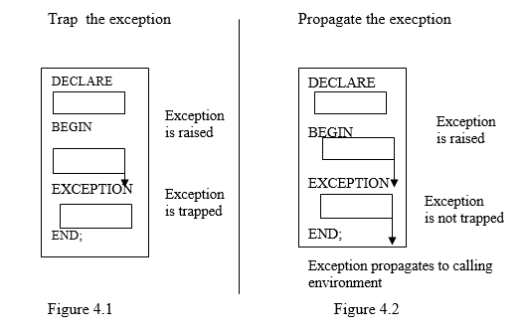

Advantages of Exceptions
Using exceptions for error handling has several advantages. These are:

With exception handling no need to check errors after each SQL command. So, errors processing is not mixed with normal processing. Without exception handling, every time you issue a command, you must check for execution errors, as follows:
BEGIN
SELECT
- check for 'no data found' error
SELECT
-- check for 'no data found' error
SELECT
--- check for 'no data found' error

In this case error processing is not clearly separated from normal processing. With exceptions, you can handle errors conveniently without the need to code multiple checks, as follows:

BEGIN
SELECT ...
SELECT ...
SELECT ...
...
EXCEPTION
WHEN NO_DATA_FOUND THEN -- catches all no data found' errors
END;

So, the exception provides the mechanism to handle multiple errors, without intermixing the error checks with normal code.

Exceptions improve readability by letting you isolate error-handling routines.

Exceptions also improve reliability. You need not worry about checking for an error at every point it might occur. Just add an exception handler to your PL/SQL block. If the exception is ever raised in that block (or any sub-block), you can be sure it will be handled.

All error conditions can be captured with OTHERS clause in the exception handler, which provides a mechanism to process all expected errors as well as those unforeseen.

Exception Types
There are two types of exceptions:
- Implicitly raised exceptions
- Explicitly raised exceptions

Implicitly raised exceptions
PL/SQL provides a predefined set of exceptions that are implicitly raised (automatically raised) by the system at run time in case an error is encountered in PL/SQL.

There are two types of implicitly raised exceptions:
- Predefined Oracle Server
- Non-predefined Oracle Server

Explicitly raised exceptions
User can also define their own set of user-defined exceptions and explicitly raise them on encountering an error condition.

Trapping Predefined Oracle Server errors
PL/SQL has a set of exceptions that are predefined for the common Oracle system errors. Predefined exceptions are used to detect and handle Oracle system errors that occur internally at program run time.
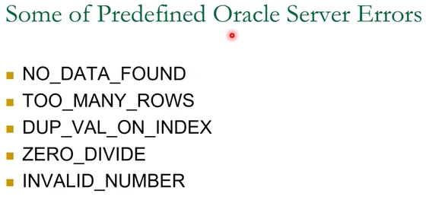

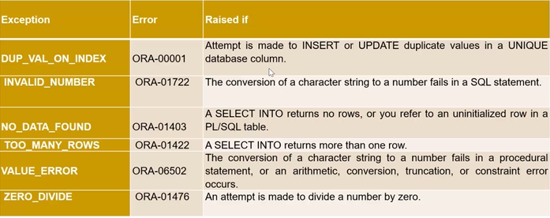

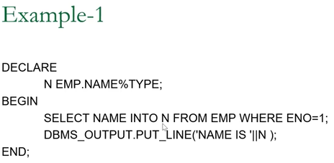

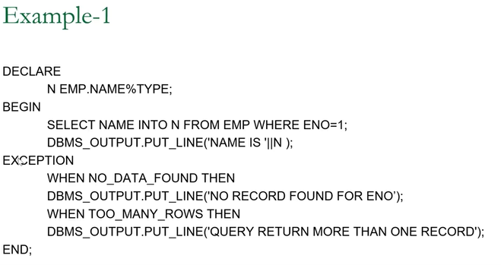

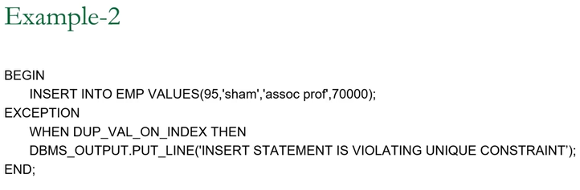

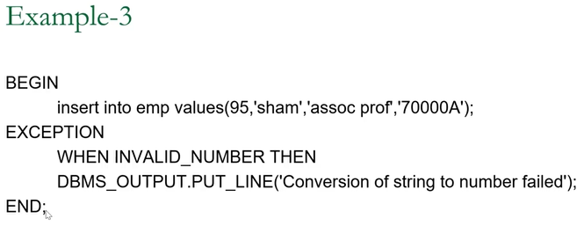

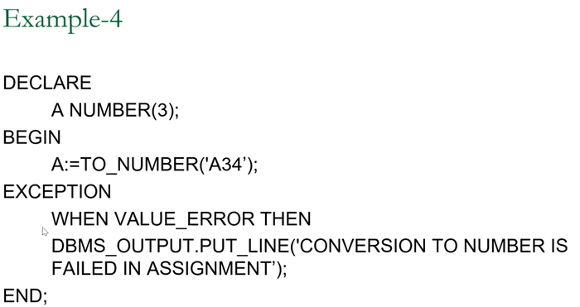

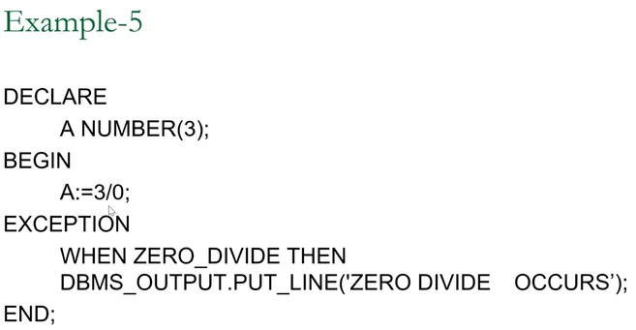

An internal exception is raised implicitly whenever your PL/SQL program violates an Oracle rule or exceeds a system-dependent limit. Every Oracle error has a number, but exceptions must be handled by name. So, PL/SQL predefines some common Oracle errors as exceptions. For example, PL/SQL raises the predefined exception NO_DATA_FOUND if a SELECT INTO the statement returns no rows.

Syntax:
EXCEPTION
WHEN exception1 [OR exception2 ………] THEN
statement1;
statement2;
…………
………….
[WHEN exception3 [OR exception4 ………] THEN
statement1;
statement2;
……………
……………
..…………..]
[WHEN OTHERS THEN
statement1;
statement2;
……..
……..];

In the syntax
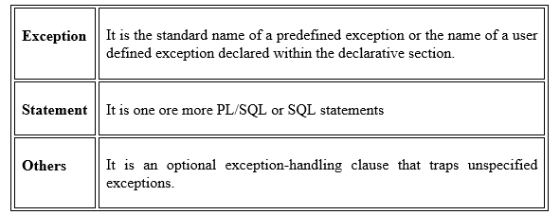

WHEN OTHERS Exception Handler
The exception-handling section traps only those exceptions specified; any other exceptions are not trapped unless you use the OTHERS exception handler. This traps any exception not yet handled. For this reason, OTHERS is the last exception handler defined. The OTHERS handler traps all exceptions not already trapped.

Some Guidelines to Trap Exception
• Begin the exception-handling section of the block with the keyword EXCEPTION.
• Define several exception handlers, each with its own set of actions, for the block.
• When an exception occurs, PL/SQL processes only one handler before leaving the block.
• Place the OTHERS clause after all other exception-handling clauses.
• You can have at most one OTHERS clause.
• Exceptions cannot appear in assignment statements or SQL statements.

Example: To show use of inbuilt exceptions.

DECLARE
item_code NUMBER;
BEGIN
SELECT code INTO item_code From try
WHERE code=5;
EXCEPTION
WHEN TOO_MANY_ROWS THEN
DBMS_OUTPUT.PUT_LINE('TOO MANY ROWS');
WHEN NO_DATA_FOUND THEN
DBMS_OUTPUT.PUT_LINE('NO DATA FOUND');
END;

Trapping of Non-Predefined Oracle Server errors Or User-defined System
PL/SQL provides a limited set of predefined exceptions for the internal oracle system errors, but it provides a mechanism to declare user-defined exceptions to handle the other unnamed Oracle System errors. An exception variable can be defined and linked to the error using the PRAGMA EXCEPTION_INIT statement in a block’s declarative section.

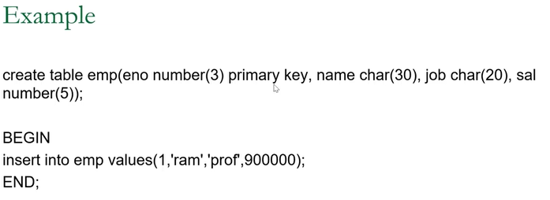

Demonstrate Trapping of Non-Predefined Oracle Server errors Or User-defined System
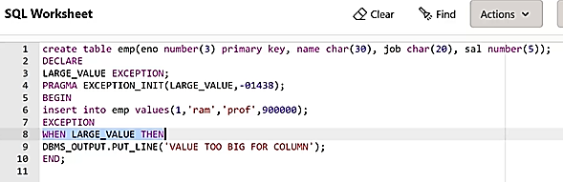

Syntax:
PRAGMA EXCEPTION_INIT (exception_name,error_number);

PRAGMA is the keyword that signifies that the statement is a compiler directive, which is processed at compile time and not at run time. Rather, it directs the PL/SQL compiler to associate an exception name with an Oracle system error number.

Example: To show use of User Defined System Exceptions
create table emp (eno number(3) primary key, name char(30), job char(20), sal number(5);
DECLARE
large_value EXCEPTION;
PRAGMA EXCEPTION_INIT(LARGE_VALUE,-01438);
NUMBER_CONVERSION EXCEPTION;
PRAGMA EXCEPTION_INIT(NUMBER_CONVERSION,-06502);
A NUMBER(3);
BEGIN
A := TO_NUMBER(' 45A ');
INSERT INTO emp VALUES(1,'john','prof',80000);
EXCEPTION
WHEN NUMBER_CONVERSION THEN
DBMS_OUTPUT.PUT_LINE('Conversion to number fails');

WHEN large_value THEN
DBMS_OUTPUT.PUT_LINE('VALUE TOO BIG');
END;

Description:
The insert statement tries to insert code, description, and chair into the table try. If any of the values specified is larger than column width user-defined exception LARGE VALUE will be invoked. (01438 is the error number for the error ‘inserted value too large for column’).

Trapping User-defined Exceptions
User-defined exceptions are used to handle error conditions specific to an application program. For example in the case of the Library system the date of the issue of a book cannot be more than the date of return, if that happens then an error must be raised explicitly by the application programmer, and that facility is developed with the help of User-defined exceptions. Unlike predefined exceptions, user-defined exceptions must be declared and must be raised explicitly by RAISE statements.

Exception and variable declarations are similar. But remember, an exception is an error condition, not a data item. Unlike variables, exceptions cannot appear in assignment statements or SQL statements. However, the same scope rules apply to variables and exceptions.

Example: In the following example, user-defined exception is raised when an item become out of stock.
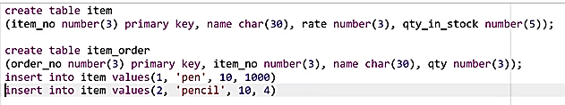

declare
out_of_stock EXCEPTION;
rec item%rowtype;
begin
select * into rec from item where item_no=1;
if qty_in_stock < 5 then
raise out_of_stock;
end if;

dbms_output.put_line('qty_in_stock' || rec.qty_in_stock);

exception
when out_of_stock then
insert into item_order value(1,rec.item_no,rec.name,100);
dbms_output.put_line('order placed successfully');
end;

We can also raise a predefined exception explicitly as shown below.
DECLARE
acct_type INTEGER;
...
BEGIN
.………..
…………
IF acct_type NOT IN (1, 2, 3) THEN
RAISE INVALID_NUMBER; -- raise predefined exception
END IF;
.…………
EXCEPTION
WHEN INVALID_NUMBER THEN
ROLLBACK;
.……….
END;

Error Trapping Functions
In an exception handler, you can use the functions SQLCODE and SQLERRM to find out which error occurred and to get the associated error message.
- For internal exceptions, SQLCODE returns the number of the Oracle error. The number that SQLCODE returns is negative unless the Oracle error is no data found, in which case SQLCODE returns +100. SQLERRM returns the corresponding error message. The message begins with the Oracle error code.
- For user-defined exceptions, SQLCODE returns +1 and SQLERRM returns the message: User-Defined Exception
- If no exception has been raised, SQLCODE returns zero and SQLERRM returns the message: ORA-0000: normal, successful completion.

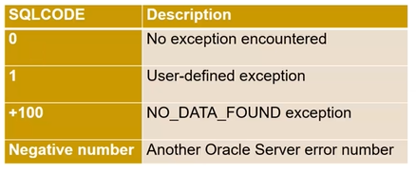

The maximum length of an Oracle error message is 512 characters. SQLCODE or SQLERRM cannot be directly used in a SQL statement. Instead, their values must be assigned to local variables, which can be used in the SQL statement.

Example: To show the use of Error trapping functions.
DECLARE
err_num NUMBER;
err_msg CHAR(100);
BEGIN
………
EXCEPTION
………..
WHEN OTHERS THEN
err_num:=SQLCODE;
err_msg:=SUBSTR(SQLERRM,1,100);
INSERT INTO errors VALUES (err_num, err_msg);
END;
The maximum length of an Oracle error message is 512 characters,so truncate the value of SQLERRM to a known length before attempting to write it to a variable.

How Exceptions Propagate?
When an exception is raised, if PL/SQL cannot find a handler for it in the current block or subprogram, the exception propagates. That is, the exception reproduces itself in successive enclosing blocks until a handler is found or there are no more blocks to search. In the latter case, PL/SQL returns an unhandled exception error to the host environment.

Sample 1
*since the error is in the declare block, it is not trapped or handled by the exception in the begin-end block
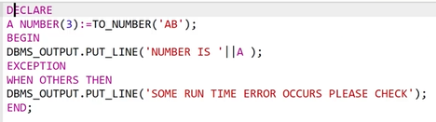

Let us extend the code above by using an “enclosing block”
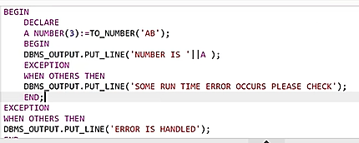

An exception can propagate beyond its scope, that is, beyond the block in which it was declared. Consider the following example:
BEGIN
DECLARE ---------- sub-block begins
past_due EXCEPTION;
BEGIN
IF ... THEN
RAISE past_due;
END IF;
END; ------------- sub-block ends
EXCEPTION
WHEN OTHERS THEN
ROLLBACK;
END;

Description:
Because the block in which it was declared has no handler for the exception named past_due, it propagates to the enclosing block. But, according to the scope rules, enclosing blocks cannot reference exceptions declared in a sub-block. So, only an OTHERS handler can catch the exception.

Reraising of an Exception
Sometimes, we want to reraise an exception, that is, handle it locally, then pass it to an enclosing block. For example, we might want to roll back a transaction in the current block, then log the error in an enclosing block. To reraise an exception, simply place a RAISE statement in the local handler, as shown in the following example:
DECLARE
out_of_balance EXCEPTION;
BEGIN
...
BEGIN ---------- sub-block begins
IF ... THEN
RAISE out_of_balance; -- raise the exception
END IF;
EXCEPTION
WHEN out_of_balance THEN
-- handle the error
RAISE; -- reraise the current exception
END; ------------ sub-block ends
EXCEPTION
WHEN out_of_balance THEN
-- handle the error differently
END;

Omitting the exception name in a RAISE statement-allowed only in an exception handler-reraises the current exception.

Handling Raised Exceptions
When an exception is raised, normal execution of your PL/SQL block or subprogram stops and control transfers to its exception-handling part, which is formatted as follows:

EXCEPTION
WHEN exception_name1 THEN -- handler
sequence_of_statements1
WHEN exception_name2 THEN -- another handler
sequence_of_statements2
...
WHEN OTHERS THEN -- optional handler
sequence_of_statements3

To catch raised exceptions, you must write exception handlers. Each handler consists of a WHEN clause, which specifies an exception, followed by a sequence of statements to be executed when that exception is raised. These statements complete execution of the block or subprogram; control does not return to where the exception was raised. In other words, you cannot resume processing where you left off.

The optional OTHERS exception handler, which is always the last handler in a block or subprogram, acts as the handler for all exceptions not named specifically. Thus, a block or subprogram can have only one OTHERS handler.

As the following example shows, use of the OTHERS handler guarantees that no exception will go unhandled:
EXCEPTION
WHEN ... THEN
-- handle the error
WHEN ... THEN
-- handle the error
WHEN OTHERS THEN
-- handle all other errors
END;

Multiple exceptions execute same statements
If you want two or more exceptions to execute the same sequence of statements, list the exception names in the WHEN clause, separating them by the keyword OR, as follows:
EXCEPTION
WHEN over_limit OR under_limit OR VALUE_ERROR THEN
-- handle the error

If any of the exceptions in the list is raised, the associated sequence of statements is executed. The keyword OTHERS cannot appear in the list of exception names; it must appear by itself.

You can have any number of exception handlers, and each handler can associate a list of exceptions with a sequence of statements. However, an exception name can appear only once in the exception-handling part of a PL/SQL block or subprogram.

Exceptions Raised in Declarations
Exceptions can be raised in declarations by faulty initialization expressions. For example, the following declaration raises an exception because the constant limit cannot store numbers larger than 999:
DECLARE
limit CONSTANT NUMBER(3) := 5000; -- raises an exception
BEGIN
...
EXCEPTION
WHEN OTHERS THEN ... -- cannot catch the exception
END;

Handlers in the current block cannot catch the raised exception because an exception raised in a declaration propagates immediately to the enclosing block.

Exceptions Raised in Handlers
Only one exception at a time can be active in the exception-handling part of a block or subprogram. So, an exception raised inside a handler propagates immediately to the enclosing block, which is searched to find a handler for the newly raised exception. From there on, the exception propagates normally. Consider the following example:
EXCEPTION
WHEN INVALID_NUMBER THEN
INSERT INTO ... -- might raise DUP_VAL_ON_INDEX
WHEN DUP_VAL_ON_INDEX THEN ... -- cannot catch the exception

Branching to or from an Exception Handler
A GOTO statement cannot branch to an exception handler; nor can it branch from an exception handler into the current block. For example, the following GOTO statement is illegal:
DECLARE
pe_ratio NUMBER(3,1);
BEGIN
DELETE FROM stats WHERE symbol = 'XYZ';
SELECT price / NVL(earnings, 0) INTO pe_ratio FROM stocks
WHERE symbol = 'XYZ';
<<my_label>>
INSERT INTO stats (symbol, ratio) VALUES ('XYZ', pe_ratio);
EXCEPTION
WHEN ZERO_DIVIDE THEN
pe_ratio := 0;
GOTO my_label; -- illegal branch into current block
END;

However, a GOTO statement can branch from an exception handler into an enclosing block.

Unhandled Exceptions
Remember, if it cannot find a handler for a raised exception, PL/SQL returns an unhandled exception error to the host environment, which determines the outcome. For example, in the Oracle Precompilers environment, any database changes made by a failed SQL statement or PL/SQL block are rolled back. You can avoid unhandled exceptions by coding an OTHERS handler at the topmost level of every PL/SQL block and subprogram.

